ASSESSMENT – 2
Name: SHAIK THOUHID | Register Number:192421280
Course Code: ITA0609 MACHINE LEARNING

1. Machine Learning System for Health Analysis
Design a machine learning system for health analysis to predict diseases such as heart disease or diabetes using patient data including age, blood pressure, glucose level, and lifestyle factors. Explain the choice of suitable algorithms and justify their selection. Describe the steps involved in data preprocessing, feature selection, and model training to ensure accurate and reliable predictions.
Introduction
The proposed system is a supervised machine learning classification system. It learns patterns from previous patient records in which the disease status is already known, and then predicts the risk of disease for a new patient. The input may include age, blood pressure, glucose level, body mass index, cholesterol, smoking habit, physical activity, diet, family history, and other clinically relevant factors. The output can be a binary result such as disease present or absent, together with a probability or risk level.
Proposed System Workflow
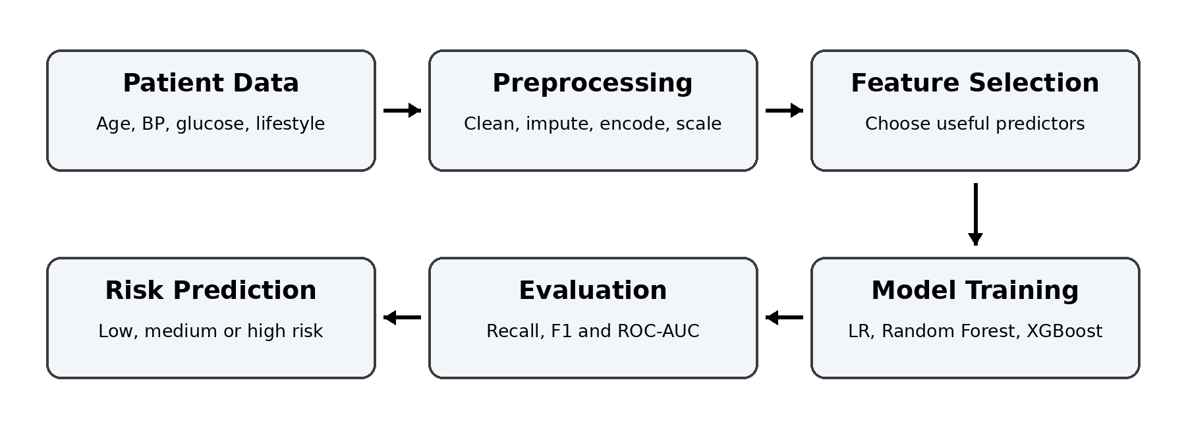
Figure 1: Workflow of the proposed health analysis system
Choice of Suitable Algorithms
A combination of interpretable and high-performance algorithms is suitable. Logistic Regression can be used as the baseline model because it provides an understandable probability and shows how each factor affects disease risk. Random Forest is recommended as the main model because medical risk often depends on nonlinear relationships and interactions among several attributes. XGBoost can also be tested as an advanced model because it usually gives strong predictive performance on structured patient data.
Algorithm | Purpose | Justification
Logistic Regression | Baseline and interpretable model | Simple, fast, gives disease probability, and allows doctors to understand the direction of important risk factors.
Random Forest | Recommended main classifier | Handles nonlinear patterns, interactions, mixed features, and is less sensitive to noise and outliers than a single decision tree.
XGBoost | High-performance comparison model | Builds trees sequentially to reduce errors and often performs very well on tabular healthcare datasets.
Data Preprocessing
- Data collection and checking: Combine patient records from reliable hospital or health datasets, remove duplicate records, verify measurement units, and check that the target label is correct.
- Missing values: Replace missing numerical values such as glucose or blood pressure with the median, and replace missing categorical values such as smoking status with the mode or an “Unknown” category.
- Outliers and impossible values: Detect values such as zero blood pressure or unrealistic glucose readings. Clinically valid extreme values must be retained, while data-entry errors should be corrected or removed.
- Encoding categorical data: Convert lifestyle factors such as smoking, exercise level, diet type, and family history into numerical form using binary or one-hot encoding.
- Feature scaling: Standardize numerical attributes for Logistic Regression and similar algorithms so that large-value features do not dominate smaller-value features. Tree-based models do not strictly require scaling.
- Class imbalance: If disease-positive cases are fewer than negative cases, use class weights or SMOTE only on the training set. This improves the model’s ability to detect high-risk patients.
- Dataset split: Use a stratified split such as 70% training, 15% validation, and 15% testing so that the disease ratio remains similar in every subset.
Feature Selection
Feature selection removes irrelevant or repeated attributes and improves model reliability. First, retain medically meaningful factors such as age, systolic blood pressure, glucose, BMI, cholesterol, family history, and lifestyle behaviour. Remove any variable that directly reveals the final diagnosis because it would cause data leakage. Next, eliminate constant features and highly correlated duplicates. Statistical methods such as correlation, chi-square test, and mutual information can be used to measure usefulness. Recursive Feature Elimination or Random Forest feature importance can then identify the strongest subset. The final features should be confirmed using cross-validation rather than selected from the test set.
Model Training and Evaluation
Step | Activity | Description
1 | Train the baseline | Fit Logistic Regression on the training set to obtain a simple and interpretable benchmark.
2 | Train advanced models | Train Random Forest and XGBoost using the same selected features.
3 | Tune hyperparameters | Use stratified k-fold cross-validation and grid or random search to choose tree depth, number of trees, learning rate, and regularization.
4 | Evaluate correctly | Measure recall or sensitivity, specificity, precision, F1-score, ROC-AUC, and confusion matrix. Recall is especially important because missing a diseased patient can be dangerous.
5 | Select threshold | Choose a probability threshold that gives an acceptable balance between detecting disease and avoiding unnecessary false alarms.
6 | Final testing | Evaluate the chosen model once on the untouched test set to estimate real performance on unseen patients.
Ensuring Accurate and Reliable Predictions
- Use cross-validation and an untouched test set to prevent overfitting and obtain an honest performance estimate.
- Check probability calibration so that a predicted risk of 80% represents a genuinely high-risk group.
- Use feature importance or SHAP explanations to show the factors that contributed to each prediction.
- Test the model across age groups and other patient groups to detect bias and unequal performance.
- Monitor the deployed model and retrain it when patient patterns or data collection methods change.
- Use the system as clinical decision support and not as a replacement for a qualified medical professional.
Expected Output
Input Example | Model Output
Age 55, high blood pressure, high glucose, smoker, low physical activity | Heart disease risk: 82% – High Risk  Recommended action: clinical examination and further tests
Conclusion
The system should compare Logistic Regression, Random Forest, and XGBoost, with Random Forest or XGBoost selected when they provide better validated performance. Careful preprocessing, leakage-free feature selection, cross-validation, suitable medical metrics, and interpretable risk explanations make the prediction more accurate and reliable. The final model can assist early screening for heart disease or diabetes, but the prediction must be confirmed by healthcare professionals.
2. Application of the Find-S Algorithm for Loan Approval
In the context of the Find-S algorithm, consider a dataset used to determine whether a loan should be approved based on attributes such as Employment Status, Salary Level, Credit Score, and Loan History. Apply the Find-S algorithm to derive the most specific hypothesis consistent with the positive examples.
Given Dataset
Example | Employment | Salary | Credit Score | Loan History | Loan Approved
1 | Employed | High | Good | Clean | Yes
2 | Employed | Medium | Good | Clean | Yes
3 | Unemployed | Low | Poor | Bad | No
4 | Employed | Medium | Excellent | Clean | Yes
Find-S Algorithm
Find-S begins with the most specific possible hypothesis and examines only positive training examples. When a positive example contains a value different from the current hypothesis, that attribute is generalized to “?”, meaning that any value is accepted. Negative examples are ignored by the basic Find-S procedure.
Symbol | Meaning
Ø | No value accepted; the most specific condition
? | Any value is accepted for that attribute
Step-by-Step Derivation
Step | Training Example | Action | Current Hypothesis
Initial | None | Start with the most specific hypothesis. | H0 = <Ø, Ø, Ø, Ø>
Example 1 | <Employed, High, Good, Clean> → Yes | First positive example; copy all attribute values. | H1 = <Employed, High, Good, Clean>
Example 2 | <Employed, Medium, Good, Clean> → Yes | Salary differs (High vs Medium), so Salary becomes “?”. Other values remain the same. | H2 = <Employed, ?, Good, Clean>
Example 3 | <Unemployed, Low, Poor, Bad> → No | Negative example; ignored by Find-S. | H2 = <Employed, ?, Good, Clean>
Example 4 | <Employed, Medium, Excellent, Clean> → Yes | Credit Score differs (Good vs Excellent), so Credit Score becomes “?”. | H3 = <Employed, ?, ?, Clean>
Final Most Specific Hypothesis
H = <Employed, ?, ?, Clean>
Interpretation: A loan is predicted to be approved when the applicant is employed and has a clean loan history. Salary level and credit score may take any value according to the positive examples available in this small dataset.
Verification
Examples 1, 2, and 4 satisfy the conditions Employed and Clean Loan History, so they are classified as approved. Example 3 is unemployed and has a bad loan history, so it does not match the final hypothesis. Therefore, the hypothesis is consistent with all four given examples.
Conclusion
Find-S produces the most specific consistent hypothesis H = <Employed, ?, ?, Clean>. The common conditions are Employed and Clean Loan History. Since Find-S ignores negative examples and assumes noise-free data, a real loan approval system should use a larger dataset and more robust classifiers.

